# Assignment 3

Memory hierarchy design and analysis are the primary areas of concentration in the gem5 simulator, which provides a dynamic and all-encompassing platform for modeling and simulating computer systems. Learn how to set up and run simulations to probe cache performance and virtual memory systems with the help of this gem5 documentation that dives into the tool's practical applications. To learn how various setups affect computer systems' performance and efficiency, such simulations are essential.

# Setup and Installation of gem5

Before you can begin setting up gem5, you must guarantee that your operating system has all of the required dependencies. To begin ensuring compatibility and security, users should upgrade their system packages to the newest versions. After that, in order to compile and run the simulator, you must install the gem5 dependencies, which include GCC, Python, SCons, and the Protobuf libraries. All of the complicated simulations that gem5 can handle can be built and executed with the help of these tools. The user then proceeds to clone the gem5 source code from its official repository after ensuring that all dependencies are in place. The next stage is to compile the source code, which involves converting the downloaded code into an executable program that is customized to the user's particular system architecture, such x86 or ARM. Using the -j option with SCons, which sets the number of concurrent build jobs, helps speed up the compilation process, which can be heavy, by leveraging many cores and threads.

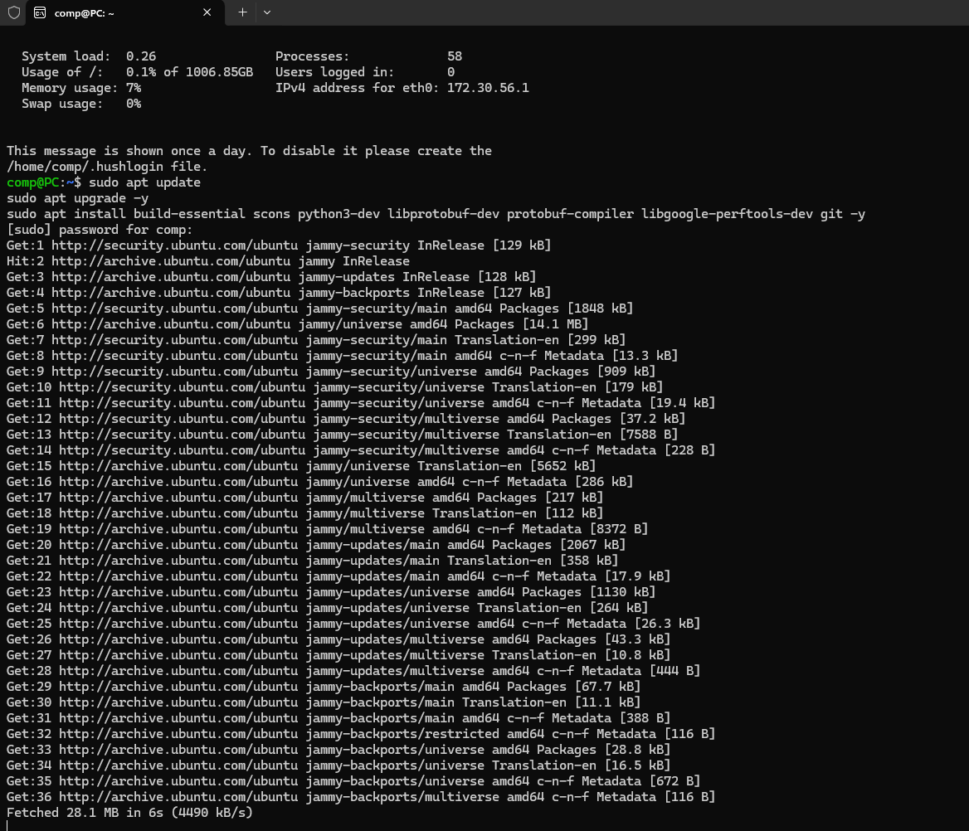

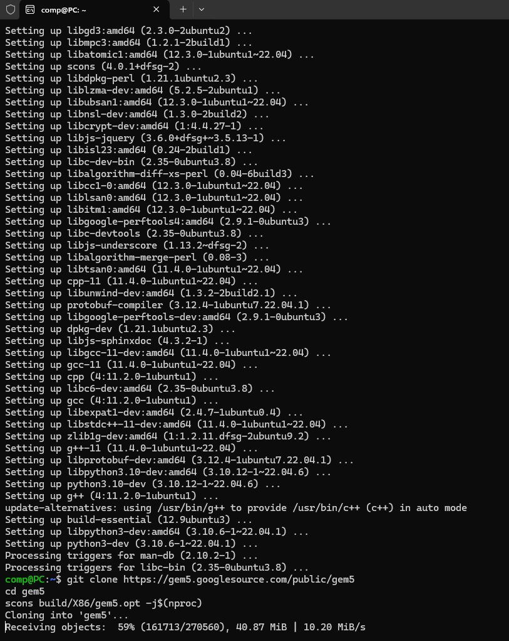

# Configuration of Simulation Environment

Scripting in Python is required to configure gem5 for simulation. This script describes the parameters and components of the system that will be simulated. The script details the memory bus connections, architecture, memory systems, central processing units, and caches. For instance, x86 systems allow users to configure replacement rules, associativity levels, and cache sizes. This configuration file is vital because it specifies the parameters that gem5 will use to run the virtual system, which in turn affects the simulation's behavior and output. Clock speed, voltage domains, and memory modes are configuration parameters that are specified in these scripts. The simulator is able to accurately simulate the interactions inside the CPU and between the CPU and memory at this level of detail, which helps to identify any inefficiencies or bottlenecks.

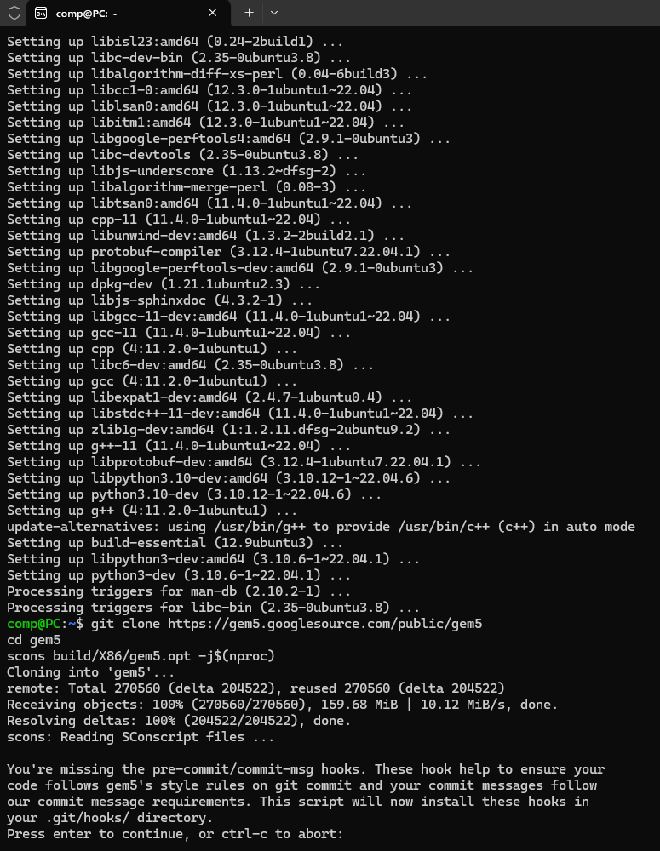

# Running Simulations and Analyzing Cache Performance

Examining the effects of various cache settings on system performance is the main objective of performing simulations in gem5. Performance parameters including hit rates, miss rates, and latency are baselined by running simulations with default cache settings initially. After that, we run simulations to see how changing cache settings like size and associativity affects performance. By repeating the tests, we may learn which cache settings perform best with various workloads. We carefully document and assess the performance of each setup. By weighing the potential advantages of various architectural choices against their potential drawbacks, such as higher latency and power consumption, these assessments provide light on the trade-offs that exist.

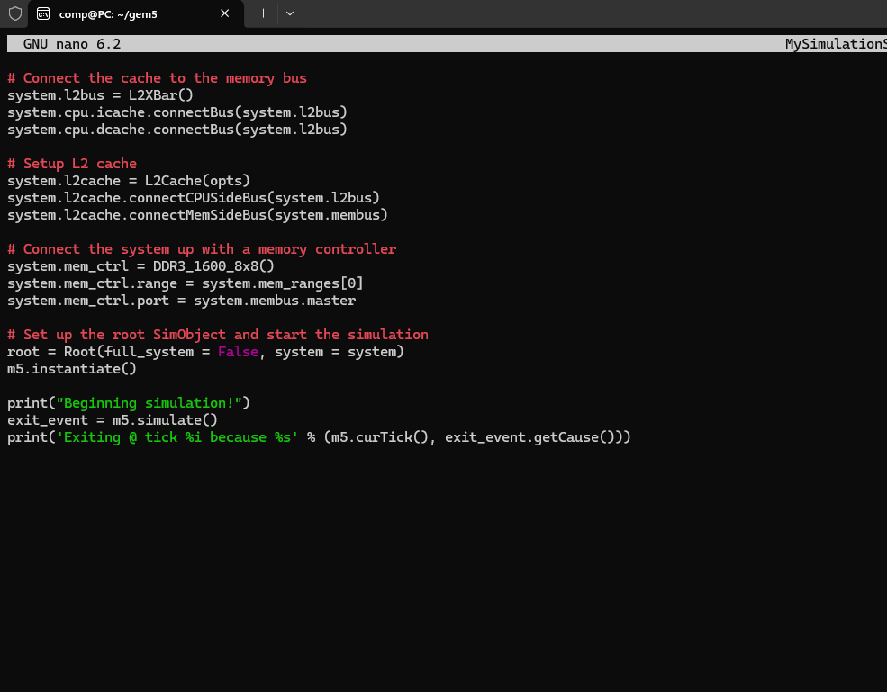

# Exploring Virtual Memory Systems

Another important topic to investigate in gem5 simulations is virtual memory. Here, you may configure things like the Translation Lookaside Buffer (TLB) settings and page size, as well as enable virtual memory in the simulation scripts. Memory management, namely the handling of page faults and TLB misses, may be drastically altered by adjusting various variables. Operating system memory management strategies and their effects on application performance may be better understood with the help of these simulations.

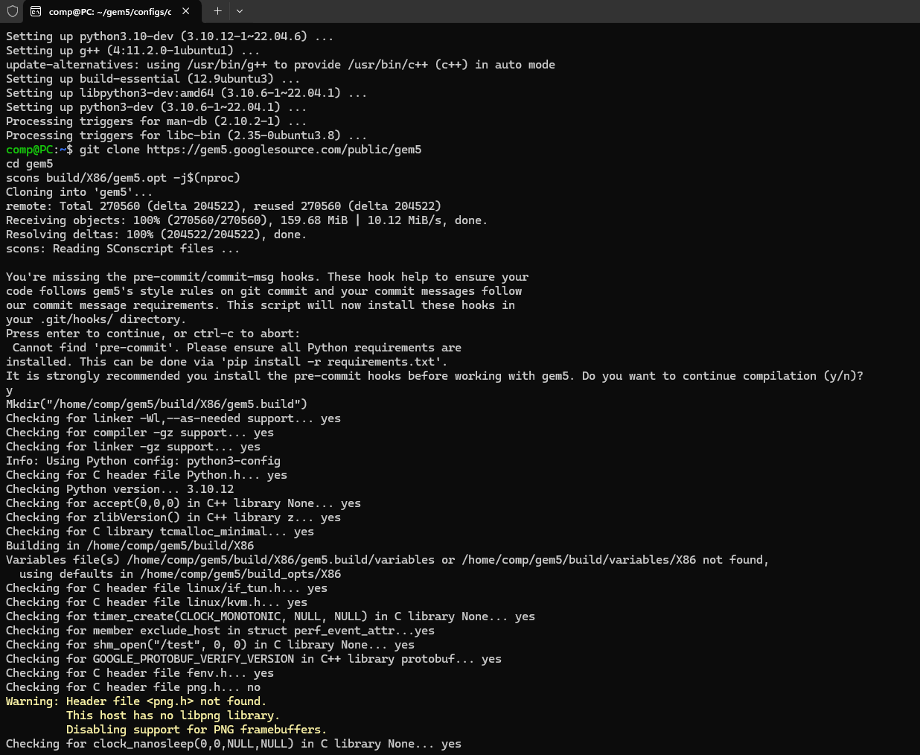

# Comprehensive Documentation and Insightful Analysis

Gem5 documentation is the last stage in the process. It includes everything from basic setup to in-depth assessments of simulation results. Documentation should not only detail actions taken, but also include explanations for testing certain settings and their effects on system performance. These effects may be better understood and the data can be more easily accessed with the inclusion of comprehensive charts and graphs. Insights into possible optimization areas in real-world systems may be gained from conclusions collected from gem5 simulations. They help close the gap between theory and practice in computer architecture by adding to our grasp of abstract ideas. Users may further their knowledge of system designs and make a contribution to the area of computer architecture research by carefully documenting the approach and results of gem5 simulations. Future research and advancements in the field may build upon this thorough investigation and analysis.